South Asian Club Presents

Diwali & Eid
$Type equation here.$
Friday, November, 6th 2009
Doors Open: 6:30 pm

Contact: Sania Malik (240-449-5915) Dress code: FORMAL

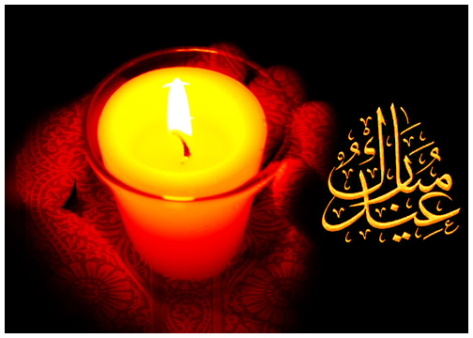

Montgomery College
Rockville Campus Theater Arts Arena (TA)
51 Mannakee Street
Rockville, MD 20850


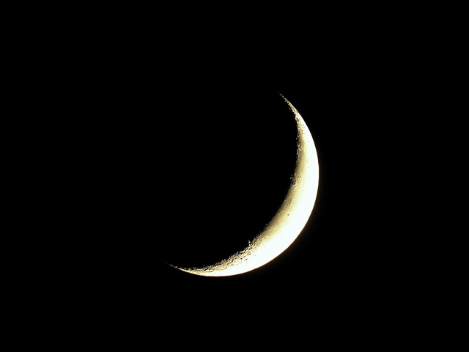
Formal Dinner

